Client server week 2 assignment

Chris Rodgers

1&2 get load and verify

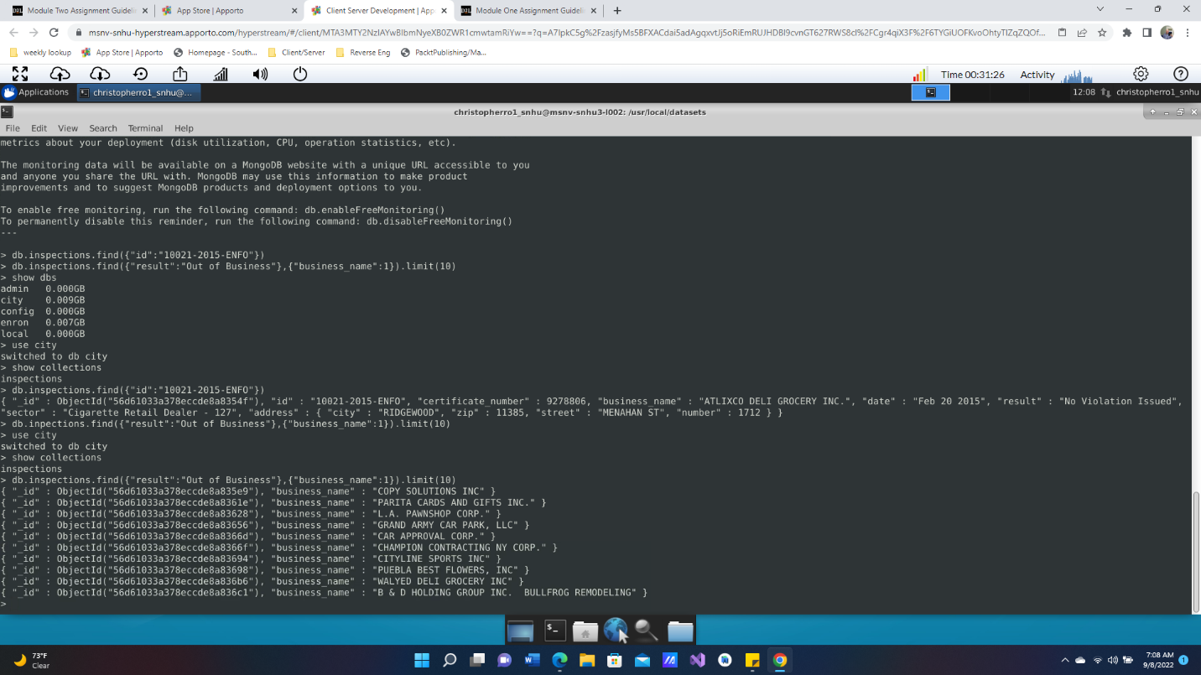

3. Insert a new document

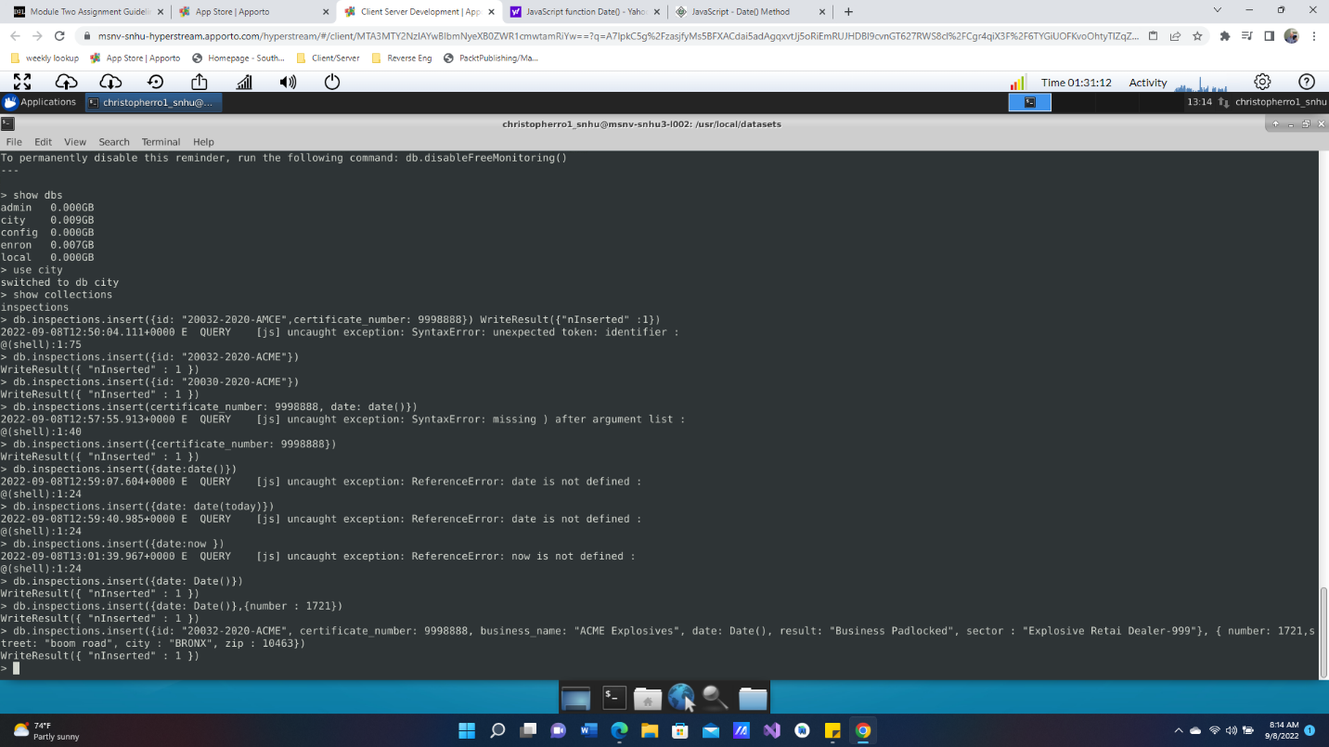

4. A- the distinct list of inspection “sector”  (Answer 87)

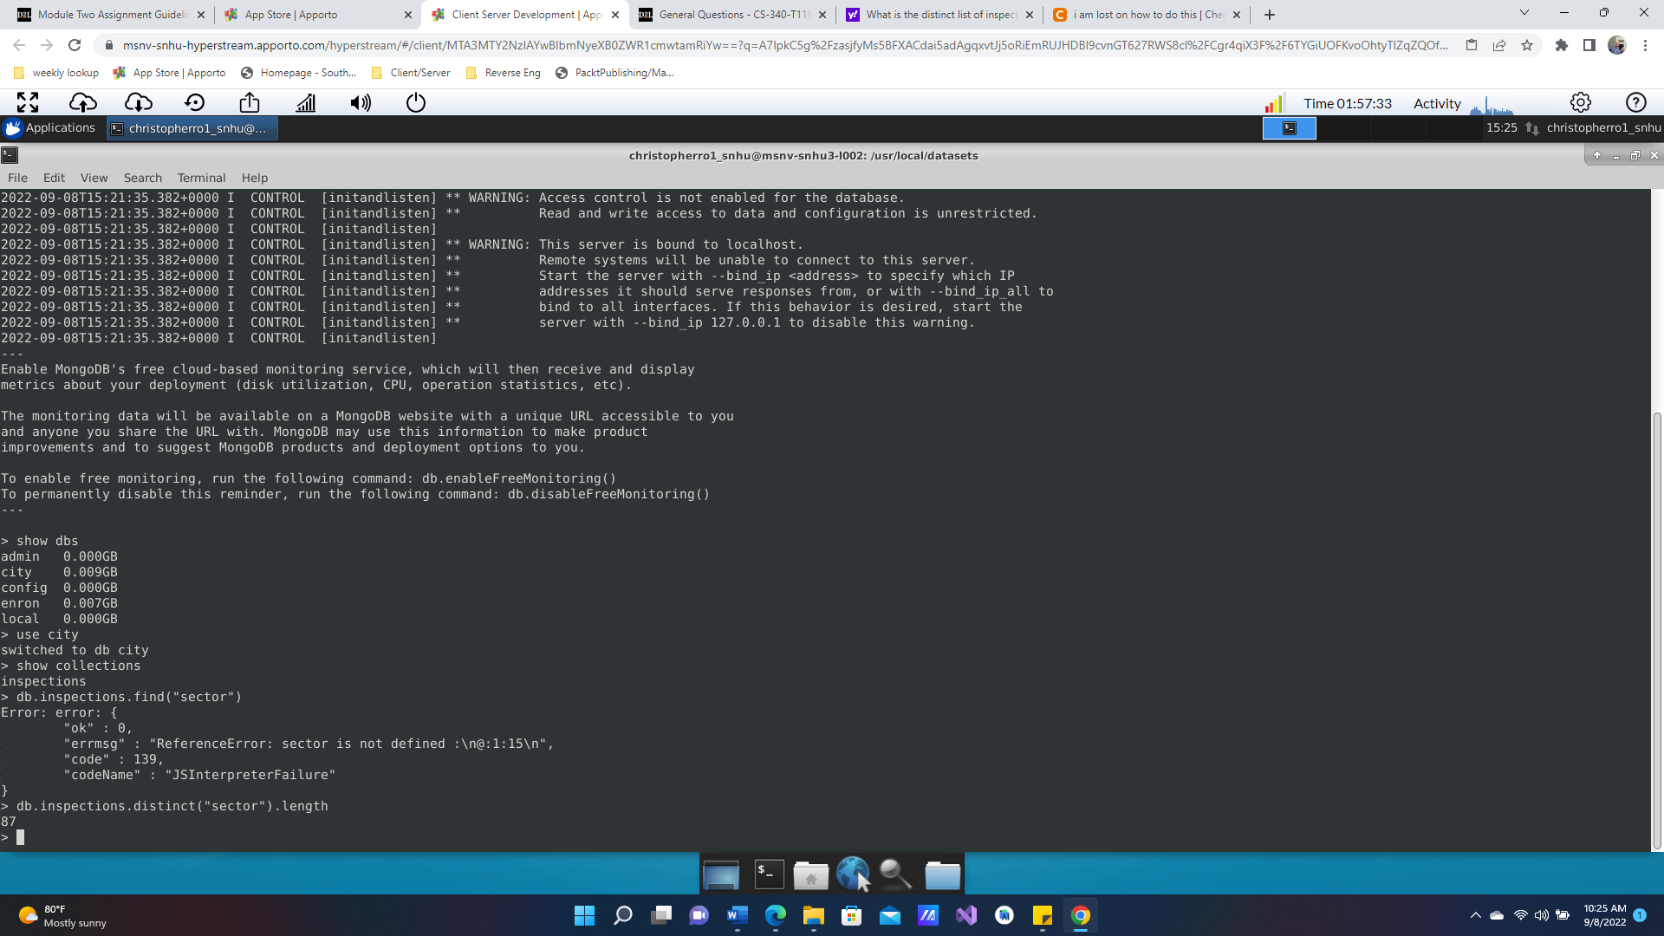

4 B – difference in the data type of date between the two (Answer Austin 2012 date has just Jan 22 2016, whereas the date of ACME has Thursday Sept 09,2022 7:30)

C- How many Violation issues (Answer: 2)

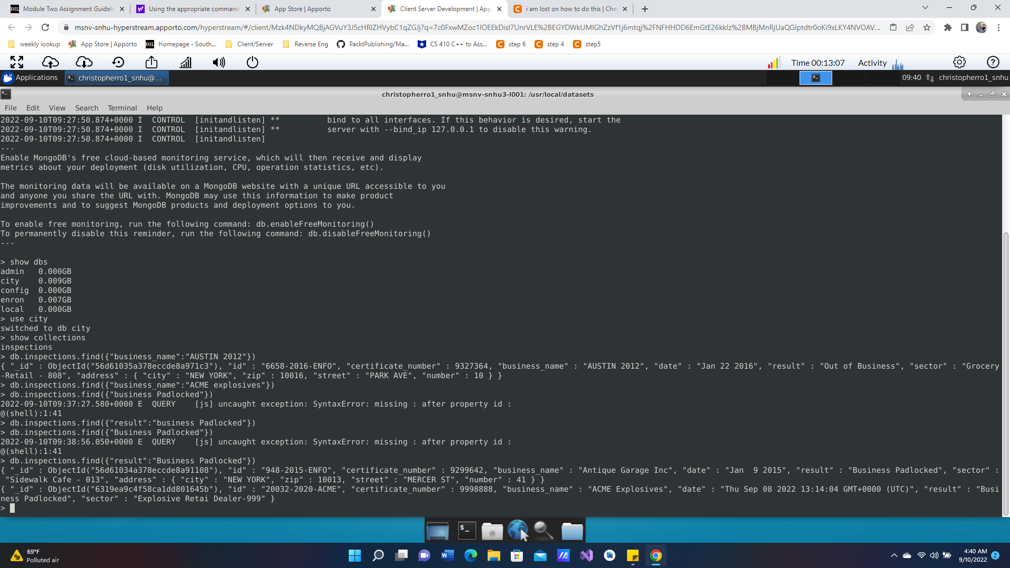

5. update document

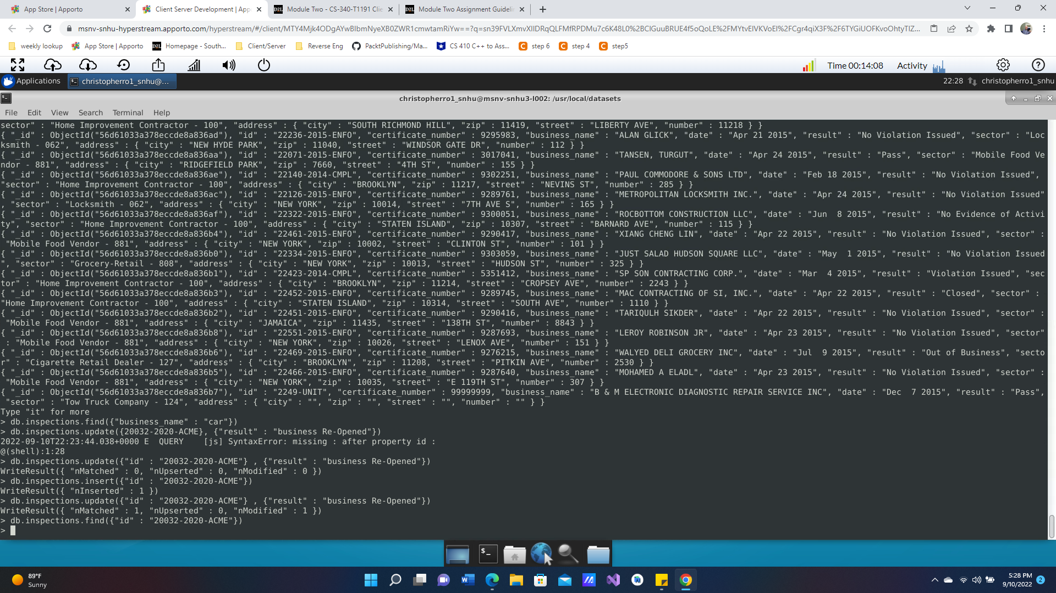

6a Update Listings

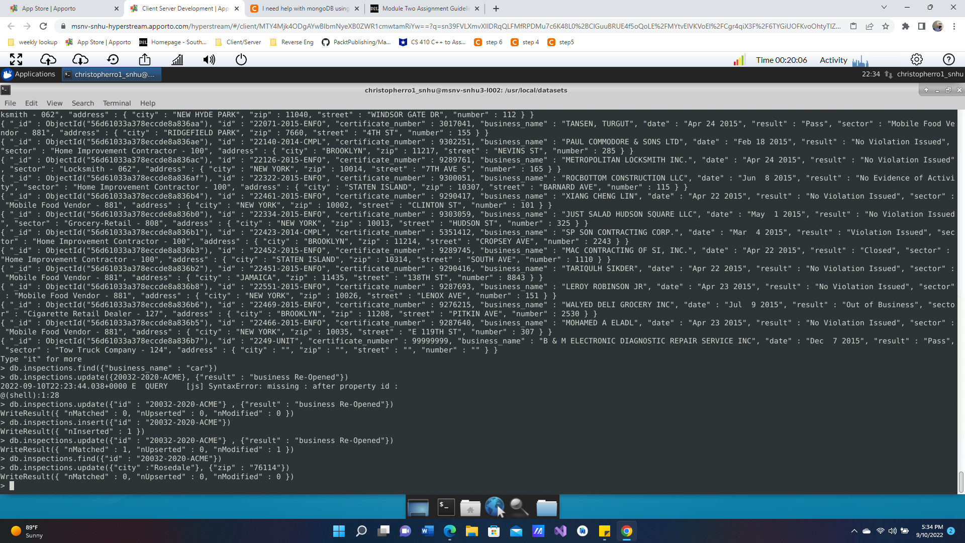

6 B – Delete a file (Did not delete because of second screen shot, where I deleted a bunch of files)